Guide to the manuscript template
- Using the styles
With the template follow several styles that can be used to format headings, text, lists etc.
You find the styles in the ribbon Home and Styles.
Select the text you want to format and click on a style.
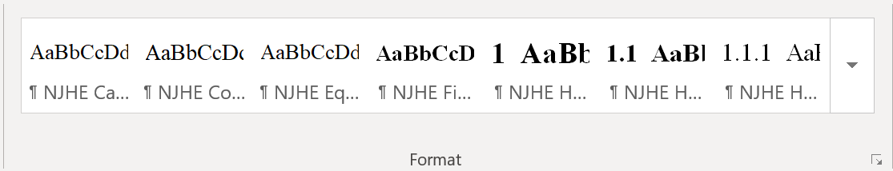

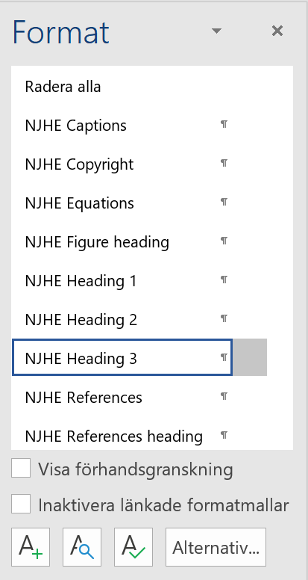
It is possible to show the styles as a list for a better view with more styles. Click on the little symbol with a small arrow pointing down and right in the lower right corner of the Styles group.

- Guidelines for images and figures
When submitting manuscripts, they need to be complete with images and figures. We encourage authors to use images and figures with as high quality as possible. We also encourage authors to use images and figures with the right final size or greater when inserting the image in the document because if the image size is increased in the document the image resolution will decrease. If the size of an image decreases the resolution will increase.

It is possible to view information such as resolution, width and height for a file. In Windows 10 it is often possible to right click on the file in the File Explorer in Windows and choose Properties and Details.
  - Resolution
    - For Peer-Review Submission
Line art like graphs, diagrams, flowcharts and other text-based figures need to have a preferred resolution of 600 dpi. A tip is to increase the font size for explaining text to make the text-based line art easier to read.
Images like photographs, equipment with imaging system outputs such as ultrasound or MRIs need to have a preferred resolution of 300 dpi.

    - For Post-Acceptance
Line art like graphs, diagrams, flowcharts and other text-based figures need to have a preferred resolution of 600 - 1000 dpi.
Images like photographs, equipment with imaging system outputs such as ultrasound or MRIs need to have a preferred resolution of 300 dpi.
  - Size
The size limit for images and figures is the page width and height of the document, A4.
If you increase the size of an image in a document the images resolution decreases.

Quick parts
Word for PC has a tool called Quick parts. With the Quick parts tool it is possible to save text, tables, illustrations etc. The manuscript template has 2 standard Quick parts built inn.
How to find and insert a Quick Part.
- Place the cursor where you want to insert the Quick Part
- Chose the ribbon Insert and Quick Parts in the group Text.
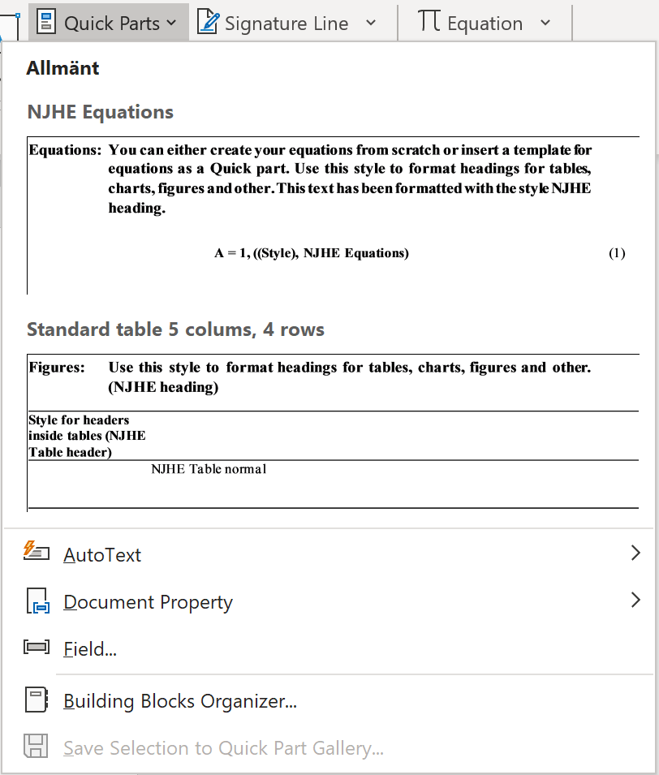
- Click on the Quick Part you want to insert
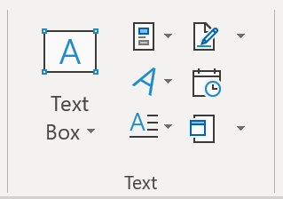
It is possible to undo inserting a Quick Part using the command Undo in the Quick Access Toolbar in the top left corner of the Word window.

When working with the template you will find Quick Parts on the Insert ribbon and the button Explore Quick parts. The button Quick Parts is also visible in the Quick Access Toolbar, top left corner in the program window.

The different Quick Parts

NJHE Equations
NJHE Equations inserts a table row with a heading and the beginning of an example equation. The text is formatted with the style NJHE Equations with the right font and format.

Standard table 5 colums, 4 rows
The quick part Standard table 5 colums, 4 rows inserts an example table with heading. The table headers are formatted with the style NJHE Table header. The style NJHE Table header can be used to format headings within the table. The style NJHE Table normal can be used to format text in tables. The whole table is formatted with the table style NJHE Table 1 which formats borders, row, columns etc.

Tables
If you create a table from the beginning, the table is being formatted automatically with the style called NJHE Table 1 in the group Table Styles under the ribbon tab Table Design when the table is selected. The ribbon tab Table Design is only visible when a table is selected or the cursor is placed within a table.

Formatting tables
When working with tables you can format the tables, fill colour and borders with the customized table style, NJHE Table 1, in the group Table Styles under the ribbon tab Table design.
When formatting the table contents there are styles for table headings, NJHE Table header, and table text, NJHE Table normal, in the Style gallery on the Home ribbon and Styles group.

