Becoming a Chemistry Teacher – Expectations for Chemistry Education Courses

Sabine Streller
Division of Chemistry Education, Freie Universitaet Berlin, Germany
sabine.streller@fu-berlin.de

Sabine Streller is a fully trained grammar school teacher for chemistry and biology. She did her PhD in chemistry education. She has several years’ experience in pre- and in-service science teacher training. Her main research interests are students' interests in science and approaches to enhance the professionalization of in-service teachers and teacher education students. She is currently a research associate and lecturer at Freie Universitaet Berlin, division of chemistry education, and is involved in the preparation of science teachers and in running CPD (continuous professional development) courses.

Claus Bolte
Division of Chemistry Education, Freie Universitaet Berlin, Germany
claus.bolte@fu-berlin.de

Claus Bolte worked as a high school teacher in chemistry and physical education. Since 2004 he is professor and head of the division of chemistry education at Freie Universitaet Berlin. His research focuses on the investigation of student-teacher-interaction, motivational learning environment research and STS-based science education. Further interest encompass on the question of how to promote students’ ability on critical thinking and proper judgement, the correlation of students’ language skills and science learning, and on how to promote language competences of migrant students in formal and informal learning environments.

Abstract
The development of professional competence is of major importance for each teacher student and in the end for the entire education system. Therefore, optimising students’ learning processes is a central goal of professional development at the university level. Learning processes are influenced by an individual’s prior knowledge, beliefs, and expectations. Having insights into the beliefs and expectations of our students should give us the opportunity to optimize their university courses. To obtain a better understanding of these beliefs and expectations we used a questionnaire with open questions. All statements of feedback from 168 students in BA/MA programmes were categorised. For this purpose, we developed a category system based on the COACTIV model of professional competence. The results indicated that many students assume that the most important influence on their future profession is the possession of self-related ability cognitions, but they do not expect to develop such cognitions in their university courses. As a consequence of these findings, the Division of Chemistry Education has begun offering students authentic learning situations with real pupils. This approach offers the chance for the students to try out the teacher role and to reflect upon the first teaching experiences. They can revise their image of the teachers’ role and acquire a realistic view of their future profession.

Introduction
When university studies are assessed retrospectively by young in-service teachers, the majority express not having been adequately prepared by university courses for the job of teaching chemistry: according to an Allerbach study, every second teacher entering the workforce indicated that their studies had been insufficient preparation for the teaching profession (Vodafone Stiftung, 2012). Such widespread dissatisfaction is concerning, as it seems to indicate a deficiency, either in the content and design of university courses or in the mentality of students in terms of adequately gleaning what these courses work to convey. University students often experience chemistry (content knowledge), science education (pedagogical content knowledge), and pedagogy (pedagogical knowledge) as partitioned areas in their studies, but the interaction between these areas is of major importance in supporting and enhancing their professionalism as future teachers (Shulman, 1986). The Division of Chemistry Education at Freie Universität Berlin tries to alter the narrow conceptions that the students have: firstly, by getting insights into the expectations and beliefs of students regarding their future profession and their related courses. Secondly, by considering these expectations and beliefs in the science education courses to come and – if necessary – by working toward developing them into a more realistic view of the future profession. Thirdly, by optimising the chemistry education courses to find a balance between subject, science education, pedagogy, and the needs of the students. In this contribution we focus on the expectations that students of chemistry education have regarding their future profession and their science education courses at university.

Theoretical background
In Germany, school education and teacher training are based on government-outlined standards (KMK, 2004), which are important for study regulations at university. The standards define the necessary requirements to be met by all teachers and provide a concrete explanation of their essential functions and skills: teachers are experts of teaching and learning. Their core task is the specific and scientifically reasoned design and subsequent reflection upon teaching and learning processes. In addition to the proper performance of their educational role, teachers undertake advisory and assessment tasks and adapt their educational competence continuously (KMK, 2004). In addition to these general tasks, the standards go on to describe more specific requirements for each subject in teacher education. For chemistry, this includes basic knowledge in organic chemistry, inorganic chemistry, physical chemistry and biochemistry as well as knowledge about chemistry education and practical teaching skills (KMK, 2008). Thus, the idea emerges from these normative requirements, as laid out in the standards, that knowledge is the foundation of good quality teaching: knowledge of the subject, knowledge about didactic mediation processes, and pedagogical knowledge. Aside from knowledge, there are certain personality traits, such as motivation, attitude, and beliefs, which determine how teachers behave within their profession and how successful they are in accomplishing their professional tasks. All of these qualifications taken together, which a person has or learns in order to meet the professional demands of the teaching career, are defined as professional competence (Kunter & Trautwein, 2013, p. 144).
The individual aspects that make up professional competence and how they work together have been compiled by experts (EC, 2013) and this compilation and classification is a current topic of ongoing investigation in empirical education research. For example, in the project COACTIV a model for professional competence combining findings from various research perspectives was developed and empirically tested (Baumert & Kunter, 2013, p. 25). This model contains aspects, domains, and facets of professional competence (such as knowledge and skills) in the context of teaching (Baumert & Kunter, 2013), see Figure 1.
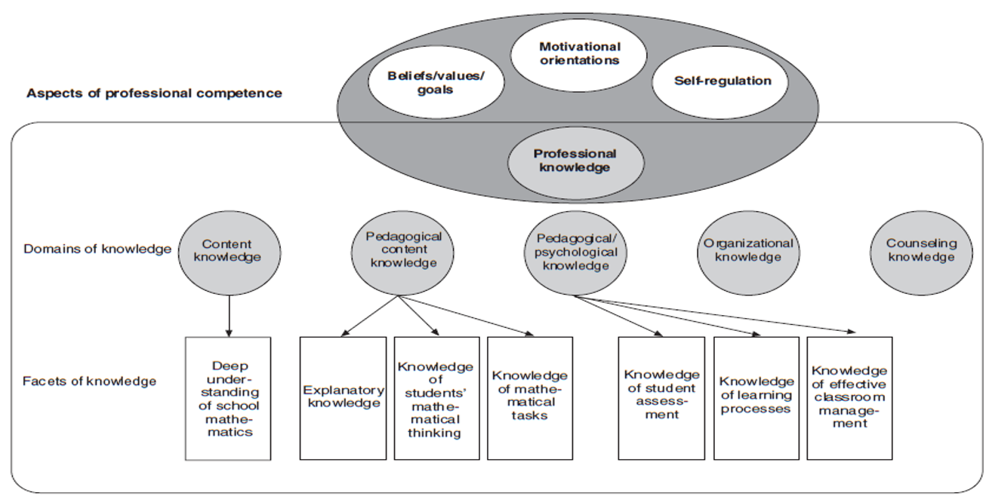
Figure 1. COACTIV model of professional competence in the context of teaching
(Baumert & Kunter, 2013, p. 29).

The individual facets of knowledge are further differentiated by indicators (Baumert & Kunter, 2013, p. 28). An indicator is described in the COACTIV model as a more detailed facet. So, the facet knowledge of student thinking is differentiated into subcategories under the indicators: knowledge of student misconceptions, knowledge of typical errors, ways of assessing student knowledge, and ways of assessing comprehension processes (these indicators are not shown in Fig. 1).

The interaction of the other three aspects of professional competence – those not assigned to the aspect of knowledge: beliefs, motivational orientation, and self-regulation – with the aspect of knowledge is what leads to professional competence. The term beliefs refers to the ideas, assumptions, and opinions of teachers concerning processes related to school and teaching. Beliefs are always subjective views and personal evaluations and cannot therefore be true or false per se. They belong to the aspects of professional competence as they have consequences upon the professional decisions made by teachers as well as the emphasis they place on their work. These ideas about how lessons and learning function are formed early, often during their own school years, and also influence their subsequent teaching (Kunter & Trautwein, 2013, p. 152). Of course, motivational aspects such as zest for action, having fun at work, or a lack of enthusiasm, as well as the ability to work autonomously, that is, to handle one’s own resources, also have a great impact on professional competence and teaching quality.

During their university studies, students should begin to develop their professional competence. In order for this to be successfully achieved, attention should also be given to the results of educational research concerning the development process. Fischler was able to show that “student-teachers often begin their programmes with fixed conceptions about teaching and learning and are not usually willing to take on alternative conceptions unless they have experienced failure when using their own ideas” (1999, p. 129). Learning prerequisites such as prior knowledge, beliefs, and expectations of the learners must first be known and understood before they can be specifically considered, since these prerequisites influence each learning process (Fischler, 1999). Professional development is no exception, but “too often the cognitive research on learning is forgotten when it comes to designing teacher’s training” (Loucks-Horsley, Stiles, Mundry, Love & Hewson, 2010, p. 53).
Reflecting on one’s own beliefs and preconceptions and consciously assessing the extent to which one’s own evaluation systems may limit professional action is an important component of professional development (Kunter & Trautwein, 2013, p.153).

Research goal
In our study we want to find out what expectations and beliefs our students express regarding their future profession as teachers and what specific expectations they have for their chemistry education courses. Since learning processes are influenced by beliefs and expectations we pursue the long goal, to optimise our chemistry education courses by taking into account the results of this study. Thus, we hope to promote the professional competence of our students on a broad scale and in an enduring manner.

Method
In order to gather insights into the beliefs and expectations regarding their future profession and their university courses, students were asked two questions in an open questionnaire:
1. What do you think is expected of you as a teacher?
2. What do you expect from your studies, especially from your chemistry education courses?

Beginning in the winter term 2012/13, 168 students who were studying to become teachers took part in this study (Table 1). In order to become a teacher in Germany, students must complete a six-semester undergraduate degree (BA) and a four-semester graduate degree (MA). Both are in two subjects (i.e. chemistry/biology or chemistry/mathematics). The first courses focusing on chemistry education and teaching in the BA programme take place in the third or fourth semester while in the subsequent MA programme, pedagogical chemistry courses begin already in the first semester. Both the BA students (N=110) as well as the MA students (N=58) took part in the study during the first chemistry education course of their respective programmes. They were allotted around 20 minutes to give written responses (with paper and pencil) for both questions.

Table 1. Sample (number of students).
 | Students
 | 2012/13 | 2013/14 | 2014/15 | 2015/16 | 2016/17
Bachelor | 37 | 26 | 18 | 29 | -
Master | - | 16 | - | 23 | 19

To categorize the answers, we developed a category system based on the COACTIV model (Figure 1). The category system contains all aspects, domains and facets as well as the concrete indicators which operationalise the facets. The aspects, domains and facets form superordinate categories and for the sub-categories we mainly use the indicators (Figure 2).

Figure 2. Category System for Question 1, based on the COACTIV model (Baumert & Kunter, 2012; EC, 2013) (Aspects: capital letters, domains in the aspect knowledge: indented, facets: further indented, indicators: further indented and marked with a pale-coloured dot).

We added sub-categories coming from the list of teacher competence areas compiled by the European Commission (EC, 2013) to differentiate: 1. the facet of knowledge of tasks (practical skills), 2. the aspect of beliefs/values/goal (disposition to team-working, commitment to promoting the learning of all students, critical reflection about one’s own teaching), and 3. the aspect of motivational orientation (disposition to ongoing professional improvement). Furthermore, we added knowledge of experiments as a sub-category under knowledge of tasks. Experiments represent a special type of task in science lessons and should therefore be reflected in a separate category. Finally, our system contains 50 categories for Question 1 and 53 categories for Question 2. The categorization proceeded using the program MaxQDA and was carried out by at least two people to ascertain the inter-rater reliability (Cohen’s κ). For this purpose, we chose the first subsample of 37 students in 2012/13 and coded all statements regarding Question 1 independently from each other, calculated κ₁, and coded all questions regarding Question 2 and calculated κ₂. The values of Cohen’s kappa are .79 regarding Question 1 and .68 regarding Question 2, both of which are satisfactory values.

Results
Both questions were usually answered by the 168 students in great detail; 821 statements could be used for analysis of Question 1 and 550 statements make up the data source to investigate Question 2 (Table 2). We will consider the results for both questions separately.

Table 2. Number of statements (differentiated by Question 1 and 2).
 | Number of statements (Question 1 and 2)
 | 2012/13 |  | 2013/14 |  | 2014/15 |  | 2015/16 |  | 2016/17
Bachelor | 182 | 110 | 123 | 80 | 72 | 48 | 153 | 114
Master |  |  | 79 | 55 |  |  | 123 | 81 | 89 | 62

Results regarding Question 1 – Expectations for the Teachers’ Role
530 statements of BA and 291 statements of MA students could be used for analysis (see Table 2). It is worth noting that few students answered in full sentences. Most gave short to very short statements, and some even just single words. We summarized the statements of undergraduate and graduate students in order to display the results in a broader context and to better present the results in their entirety.

Table 3 shows the distribution of the statements and illustrates each category with examples of the students’ statements. In the presentation of the results, we focused on the overarching categories in order to provide a clear overview. Most statements from the BA students were assigned to the aspect beliefs/values/goals (18,68%) and the facet knowledge of learning processes (18,11%) under the domain of pedagogical-psychological knowledge, and the facet explanatory knowledge (15,09%) under the domain of pedagogical-content knowledge. The majority of the statements from the MA students were assigned to the facet knowledge of learning processes (20,96%) and the aspect beliefs/values/goals (16,15%). The greatest difference between both groups of students can be found in the category explanatory knowledge (Δ = 5,81%).

Table 3. Summarised overview of BA and MA students’ statements regarding Question 1: What do you think is expected of you as a teacher?
aspect | domain | facet
 |  |  | BA N_{St}=530 |  | MA N_{St}=291 |  | examples of students’ answers
 |  |  | Σ St | % | Σ St | %
knowledge | content knowledge |  | 48 | 9,06 | 24 | 8,25 | understanding of content knowledge and the material to be taught; that I have an answer for everything; ability to connect to other themes
 | pedagogical/psychological knowledge |  | 8 | 1,51 | 5 | 1,72 | pedagogical knowledge
 | general pedagogical knowledge of instructional planning |  | 26 | 4,91 | 18 | 6,18 | plan good lessons; be able to plan exciting; high-quality lessons
 | knowledge of effective class-room management and orchestration |  | 56 | 10,56 | 27 | 9,28 | create a structure, ensure that class time is used effectively
 | knowledge of learning processes |  | 96 | 18,11 | 61 | 20,96 | to respond to different levels of perfor-mance; to prepare for later on in life; to show career prospects; to inspire pupils for the subject; how I can be motivating
 | knowledge of student assessment |  | 22 | 4,15 | 14 | 4,81 | evaluate pupils justly; fair grades
 | professional behavior in school context |  | 2 | 0,38 | 4 | 1,37 | dealing with difficult pupils
 | pedagogical content knowledge |  | 7 | 1,32 | 4 | 1,37 | pedagogical content knowledge
 | explanatory knowledge |  | 80 | 15,09 | 27 | 9,28 | be able to explain, to convey, to meaningfully break down; to reduce to the essential; appropriate level; types of approaches for different classes/ages
 | knowledge of students‘ thinking |  | 3 | 0,57 | 1 | 0,34 | individual learning needs, respond to individuals and their shortcomings; show understanding (for their problems)
 | knowledge of tasks |  | 40 | 7,55 | 25 | 8,59 | compliance with the curriculum; filling out experiment protocols
 | knowledge of experiments |  | 0 |  | 0
 | organisational knowledge |  | 1 | 0,19 | 4 | 1,37 | knowledge about the school system
 | counseling knowledge |  | 9 | 1,70 | 10 | 3,34 | role as a confidant, a counsellor, supporter; parent conferences
beliefs/values/ goals |  |  | 99 | 18,68 | 47 | 16,15 | treat all pupils the same, integrate everyone; I must be: human, patient, kind, organized, just, a good role model; be critical of oneself
motivational orientation |  |  | 21 | 3,96 | 16 | 5,50 | that I am inspired/excited; motivated; lifelong learning; educate oneself
self-regulation |  |  | 3 | 0,57 | 1 | 0,34 | stand behind my work
global statements |  |  | 9 | 1,70 | 3 | 1,03 | along with many skills, a lot is expected

Because of the high number of statements coded in the category beliefs/values/goals we wanted to gain a closer insight into this category (Figure 3).

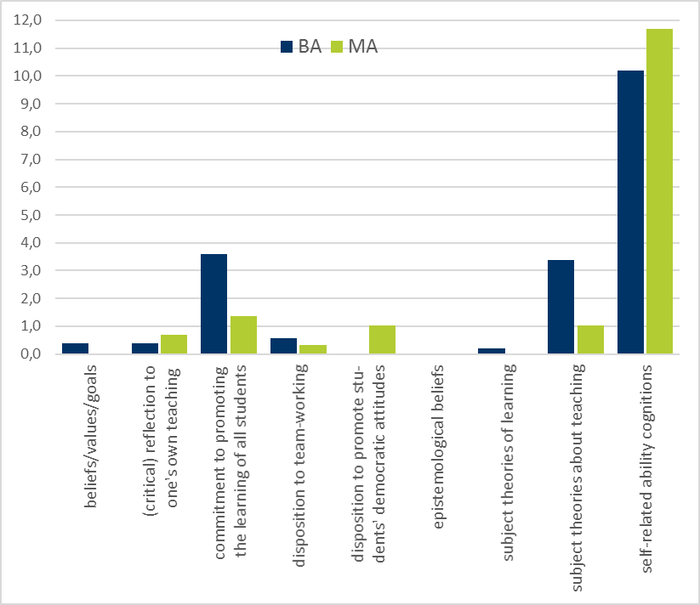

Figure 3. Aspect beliefs/values/goals – differentiated description in percent (N_{BA}=99, N_{MA}=47).

More than 10% of the statements belonging to the category beliefs/values/goals, were coded in the sub-category self-related ability cognitions (Table 3). The students expressed many attributions, for example: “as a teacher I have to be patient, punctual, polite, a role model, industrious, always fair, likeable.”

Results regarding Question 2 - Expectations for Chemistry Education
352 statements of BA and 198 statements of MA students could be used for analysis (Table 2). For Question 2, the number of statements was significantly lower than for Question 1 (550 < 821). We began by using the category system which was developed for Question 1; then in light of the data, the category system was adjusted by three categories for Question 2 (the last three rows in Table 4).

Table 4. Summarised overview of BA and MA students’ statements regarding Question 2: What do you expect from your studies, especially from your chemistry education courses?

aspect | domain | facet
 |  |  | BA N_{St}=352 |  | MA N_{St}=198 |  | examples of students‘ answers
 |  |  | Σ St | % | Σ St | %
knowledge | content knowledge |  | 3 | 0,85 | 4 | 2,02 | to have an answer for anything pupils might ask
 | pedagogical/psychological knowledge |  | 8 | 2,27 | 5 | 2,52 | learn how to teach successfully
 | general pedagogical knowledge of instructional planning |  | 54 | 15,34 | 25 | 12,63 | plan high-quality and exciting lessons
 | knowledge of effective class-room management and orchestration |  | 42 | 11,93 | 16 | 8,08 | learn how to keep control of a classroom
 | knowledge of learning processes |  | 39 | 11,08 | 13 | 6,56 | learn how to motivate pupils
 | knowledge of student assessment |  | 9 | 2,56 | 1 | 1,01 | evaluate and grade pupils fairly
 | professional behavior in school context |  | 16 | 4,54 | 7 | 3,53 | how to handle difficult situations, e.g. pupils with disabilities
 | pedagogical content knowledge |  | 9 | 2,56 | 10 | 5,05 | gain subject-specific knowledge
 | explanatory knowledge |  | 48 | 13,63 | 18 | 9,09 | learn how to explain difficult content at an appropriate level
 | knowledge of students thinking |  | 4 | 1,14 | 10 | 5,05 | understand the typical mindset of a pupil (misconceptions)
 | knowledge of tasks |  | 27 | 7,67 | 11 | 5,55 | What is taught when?
 | knowledge of experiments |  | 26 | 7,39 | 11 | 5,55 | Which experiments are suited for schools?
 | organisational knowledge |  | 15 | 4,26 | 9 | 4,55 | get information about the school system
 | counseling knowledge |  | 3 | 0,85 | 2 | 1,01 | I would like to learn how to communicate with parents.
beliefs/values/  goals |  |  | 13 | 3,69 | 4 | 2,02 | to be confident and relaxed, to appear that way
motivational orientation |  |  | 2 | 0,57 | 2 | 1,01 | to reinforce my fascination with chemistry
self-regulation |  |  | 3 | 0,85 | 8 | 4,04 | to develop my role as a teacher for my future professional life
global statements |  |  | 3 | 0,85 | 1 | 1,01 | a lot
requests about design/methods of seminars |  |  | 27 | 7,67 | 34 | 17,17 | encounter as many examples as possible of “actual” pupils, and already begin teaching early on
overview of sources (how to get material) |  |  | 1 | 0,28 | 5 | 2,52 | Where can I find good and reliable sources?
insights of current state of research |  |  | 0 |  | 2 | 1,01 | learn about the state of current research

Here, most statements of the BA students were assigned to the categories general pedagogical knowledge of instructional planning (15,34%), explanatory knowledge (12,63%), and knowledge of effective classroom management and orchestration (11,93%), while most statements of the MA students were assigned to the categories requests about design/methods of seminars (17,17%) and general pedagogical knowledge of instructional planning (12,63%). Primarily MA students expressed particular wishes concerning the design of seminars. We found the maximum difference between both groups of students in this aspect (Δ=9,5%; see Table 4). Altogether, the answers of MA students were more balanced over all categories (see Table 4). Both BA and MA students expressed their expectation to become familiar with a selection of feasible experiments and safety regulations although they made no mention of experiments at all when answering Question 1 (Table 3 and 4).

Discussion and conclusions
The category system was suitable to analyse the students’ answers; Cohens kappa was satisfactory (κ₁ .79; κ₂ .68). Although we know from theory that convictions and beliefs are strongly related to professional competence (Kunter & Trautwein 2013), we were surprised at how often the students made statements that could be attributed to the beliefs aspect. Also surprising for us, was that students of both groups assumed that self-related ability cognitions would have the most important influence on their future profession. On the other hand, they did not expect to develop such cognitions in their university courses.

After careful assessment of the data by means of our category system, we have noted the following tendencies in the mindset of the students. From their science education courses, both groups of students primarily expect to learn how to plan a lesson and to acquire explanatory knowledge. BA students want to be able to equip pupils with this knowledge of chemistry in an effective, creative, and fascinating way using various methods and teaching styles. Out of these assumptions, we see that a traditional view of learning is prevalent and the constructivist perspective on learning seems to remain unknown to them. This view is also expressed in the expectations students have for their training courses in chemistry education. Here, they wish to be equipped with a catalogue of practical examples of how to acquire the tools and techniques for lesson planning, which can help them to facilitate knowledge and instruct them on how to plan a lesson. Similar findings were also identified by Fischler in his study of physics students, that students have very stable subjective theories about teaching and learning. Even after a four-week internship at school, they often acted on their own terms: “They have experienced the narrow limits of their efforts but do not see an alternative and therefore hold on to their teaching principles with the hope of more favorable times” (Fischler, 1999 p.142). However, this traditional view on teaching seems to shift during the course of their studies. MA students, for example, also want to know more about learning processes, but in their statements we find that the perspectives develop from a teacher-centred view toward a more pupil-oriented one: ‘how can I encourage and assist a pupil?’ instead of ‘how can I facilitate the transfer of knowledge?’

One central aspect of chemistry education courses was nearly left out entirely by all the participating students: the aspect of science education research and its importance for teachers was not mentioned a single time in the sample of the BA students. These results raise an important task for us as science education researchers and educators: we have to introduce students to science education research and to present this discipline as a practically-based and research-informed counterargument to the simplistic traditional beliefs help by students. The answers given by the students in the study indicate how vital it is to stress the impact of science education research in the university courses, thus hopefully avoiding disappointment and inadequate preparation for the reality of the teaching profession.

MA students express detailed requests regarding the organisation and structure of the university courses. They want to have contact with schools and pupils during their studies and want to discuss authentic examples and situations they may have to face in schools. As expected, MA students have a more differentiated view on their studies (balanced answers). This is understandable, as they are more experienced and have a broader view on diverse aspects of (chemistry) education courses, but even for MA students educational research seems to play a minor role.

In our opinion the presented results—the beliefs and expectations our students express—are worthy of serious consideration. The BA students expressed their ideas about their future profession in detail, which gives us a good insight into the notions and beliefs with which students begin their teaching education. Regarding their expectations from the chemistry didactic training, the students also responded, but apparently have few very precise ideas about what they expect or hope for from their education. The disappointment often expressed about university education which we mentioned in the introduction (see Schumacher & Lind, 2006; Vodafone Stiftung, 2012) is, of course, also linked in part to incorrect ideas about education itself (Fischler, 1999). It is not difficult to see how students maintaining expectations based on a view that fails to align with the reality indicated by extensive research, might have difficulties adjusting to their professional situation, and might feel inadequately prepared (Schumacher & Lind, 2006). With the results of this study, we are now able to consider their wishes in a concrete way, and hopefully avoid misunderstanding and disappointment regarding the university courses. The survey of the master’s students shows that demands and expectations are shifting. This is certainly related to the advanced study and practical experience students have gained so far. We were particularly surprised and pleased that the students expressed their wishes for the design of the courses more decidedly than in the standard teaching evaluations at the end of a semester.

In our chemistry education courses, we have begun to explicitly address the areas of chemistry, chemistry education, and pedagogy. We encourage the interaction of these areas through their application in authentic learning situations for the students. This means that in an early stage of the bachelor studies, students have the opportunity to teach pupils in a classroom in order to obtain a realistic view of their future profession. They are given a chance to try out the role of the teacher, and to reflect upon their experience. Additionally, we introduce students in the bachelor programme to science education research right away and present this discipline as an important part of their professional knowledge as well as an essential component of their foundation as future science teachers. In conclusion, we would like to present an example from our courses.

Application: Practical studies in the Bachelor programme
The goal of this course is to deepen and apply the principles of chemistry education while designing a lesson at an early stage. Usually students attend the course in their fourth or fifth semester. For many students this course proves to be their earliest chance to actually try out the teacher’s role. During the course, students cooperate to develop and refine lessons in a cycle of ‘pre-discussion’, teaching and observation, as well as ‘post-discussion’. Literary resources offer explicit suggestions for the designing of practical courses (Loucks-Horsley et al. 2010, p. 206). Recommendations about the initial phases of lesson planning find practical implementation as students brainstorm about the explanation of specific chemistry basics and work in pairs to plan a 90-minute lesson for the class. Theory-based suggestions concerning methods of observation and evaluation are put into practice as the students attend and actively observe the classes taught by their fellow students, afterwards providing feedback and working together to revise the lessons.

The course focuses on the students gaining experiences by working together and teaching a school class of 7th and 8th graders. The Division of Chemistry Education cooperates with various schools in the university’s neighbourhood (Streller & Bolte, 2013). 7th and 8th grade classes are invited to participate in a one-week course or a two-day course at the university’s laboratory (Bolte, Streller & Hofstein, 2013) and during this project week, the pupils are taught by students. Before the students start to plan their lessons, they discuss their ideas with the teachers of the participating classes: which topic should be emphasized during the project week, what specific wishes do the teachers and the pupils have, and how do typical learning conditions in the classes usually look (i.e. are the pupils generally well-behaved, willing to participate, excited about the material, do they struggle with paying attention or following instructions?). This partnership is a win-win situation. For the students, the usually abstract pre-service learning situation of planning a lesson leads to an “authentic learning and teaching situation”. For the in-service teachers, the project week becomes a learning situation as well. They are introduced to topics and approaches to teaching which they might not have taken into consideration before. Moreover, they finally have the opportunity to quietly observe their pupils. For one week the pupils can experience a different learning environment focusing exclusively on science. In this arrangement, they also have a chance to deal with a topic in much more detail than is possible in the normal classroom setting with its 90-minute lessons (Figure 4).

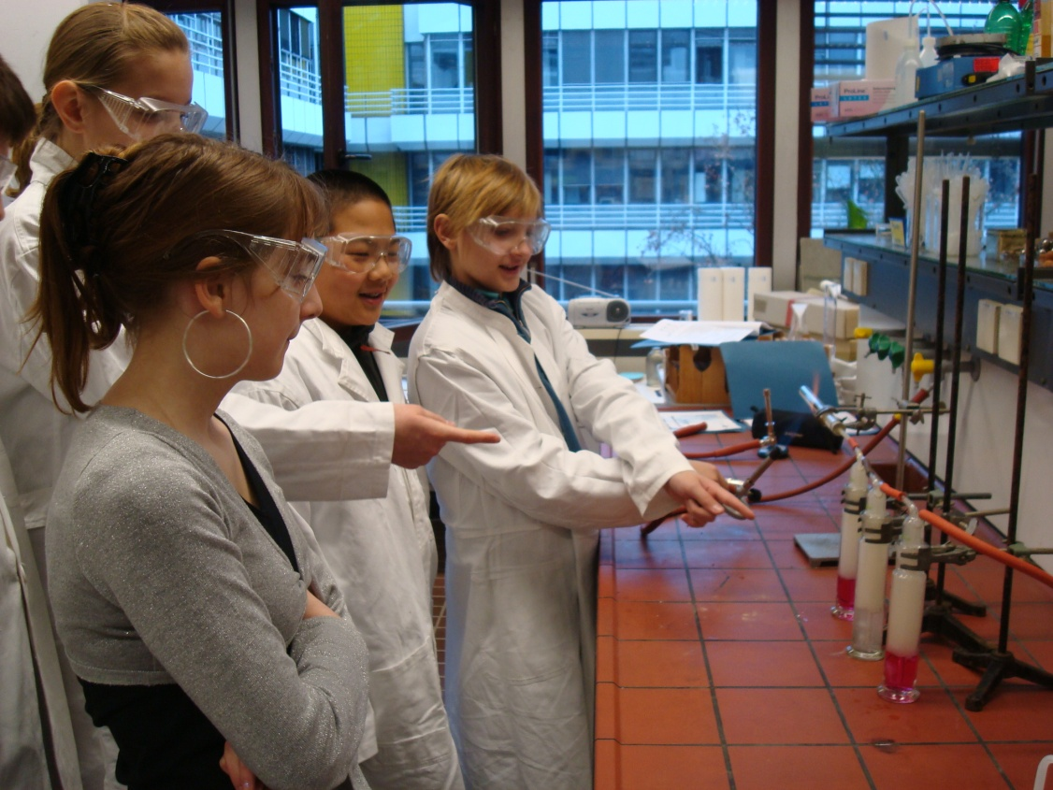
Figure 4. Pupils of grade 7 with a self-made model of a desulphurisation plant at the university laboratory.

During the preparation of this project week, all student-groups have to try out and, if necessary, modify the experiments which they plan to conduct in their lesson sequence. Moreover, materials are discussed with the lecturer of the seminar. The students also receive ample time to discuss their lesson plans with fellow students. At the end of the project week, students assess the lessons. They then use the results of these evaluations to reflect on their own lessons. Each student has the possibility to teach his or her lesson at least two times in two different classes. Students who are not teaching observe the lessons of their fellow students. At the end of each day the students discuss their lessons with their fellow pre-service education students, with the chemistry teacher of the school class and the lecturer. Of particular importance is the final reflection, in which the students consider their own experience while teaching the lesson in light of their previous expectations. In the process of writing this reflection, students revisit pedagogical theory received in earlier seminars and examine personal preconceptions juxtaposed against recent experience. Reflection on the interplay between research-based, educational scholarship and participation in an authentic classroom in the role of the teacher allows them to assess their own notion of what it means to be a teacher and provides an opportunity for a more accurate understanding of both the need for professional competence as well as the concrete application of said competence in their future career.

Acknowledgement
We would like to thank all the participating students and in particular Michelle Kube for her support in the evaluation of the questionnaires, as well as Joseph Jakubczyk for his assistance with translation and editing.

References
Baumert, J., & Kunter, M. (2013). The COACTIV Model of Teachers’ Professional Competence. In M. Kunter, J. Baumert, W. Blum, U. Klusmann, S. Krauss, & M. Neubrand (Eds.) Cognitive Activation in the Mathematics Classroom and Professional Competence of Teachers (pp. 25-48). New York: Springer. doi: 10.1007/978-1-4614-5149-5_2

Bolte, C., Streller, S., & Hofstein, A. (2013). How to Motivate Students and Raise Their Interest in Chemistry Education. In: I. Eilks & A. Hofstein (Eds.). Teaching Chemistry - a Studybook (pp. 67-95). Sense Publishers, Rotterdam. doi: 10.1007/978-94-6209-140-5_4

European Commission (2013; Ed.). Supporting Teacher Competence Development. ec.europa.eu/dgs/education_culture/.../teachercomp_en.pdf

Fischler, H. (1999). The Impact of Teaching Experiences on Student-teachers’ and Beginning Teachers’ Conceptions of Teaching and Learning Science. In J. Loughran (Ed.). Researching Teaching: Methodologies and Practices for Understanding Pedagogy (pp. 128-146). Routledge, London.

KMK - Standing Conference of the Ministers of Education and Cultural Affairs (2004). Standards for Teaching and Teacher Education. https://www.kmk.org/fileadmin/Dateien/veroeffentlichungen_beschluesse/2004/2004_12_16-Standards-Lehrerbildung-Bildungswissenschaften.pdf

KMK - Standing Conference of the Ministers of Education and Cultural Affairs (2008). Requirements for Subjects and Subject Education in Teacher Education. http://www.kmk.org/fileadmin/veroeffentlichungen_beschluesse/2008/2008_10_16_Fachprofile-Lehrerbildung.pdf

Kunter, M., & Trautwein, U. (2013). Psychologie des Unterrichts [Psychology of the Lesson]. Stuttgart: UTB.

Loucks-Horsley, S., Stiles, K. E., Mundry, S., Love, N., & Hewson, P. W. (2010). Designing Professional Development for Teachers of Science and Mathematics. Corwin, Thousand Oaks, California, 3rd ed.

Schumacher, K., & Lind, G. (2000). Praxisbezug im Lehramtsstudium. Bericht einer Befragung von Konstanzer LehrerInnen und Lehramtsstudierenden [Practical Relevance in Teaching Studies. Report on a Survey of Constance Teachers and Education Students]. Uni Konstanz. www.uni-konstanz.de%2Fag-moral%2Fpdf%2FLind-2000_lehramtsstudium-praxisbezug-Bericht.pdf&usg=AOvVaw2-aY4V1iFOeYwqjKuEK-NA

Shulman, L. (1986). Those Who Understand. Knowledge Growth in Teaching. Educational Researcher 15 (2), 4-14.

Streller, S., & Bolte, C. (2013). Translating University Chemistry for the Classroom. Chemistry in Action! No. 101, 20-26.

Vodafone Stiftung (2012). Lehre(r) in Zeiten der Bildungspanik. Eine Studie zum Prestige des Lehrerberufs und zur Situation der Schulen in Deutschland [Teaching (and the Teacher) in Times of Educational Panic. A Study on the Prestige of the Teaching Profession and the Situation of Schools in Germany]. https://www.vodafone-stiftung.de/uploads/tx_newsjson/allensbach_04_2012.pdf

